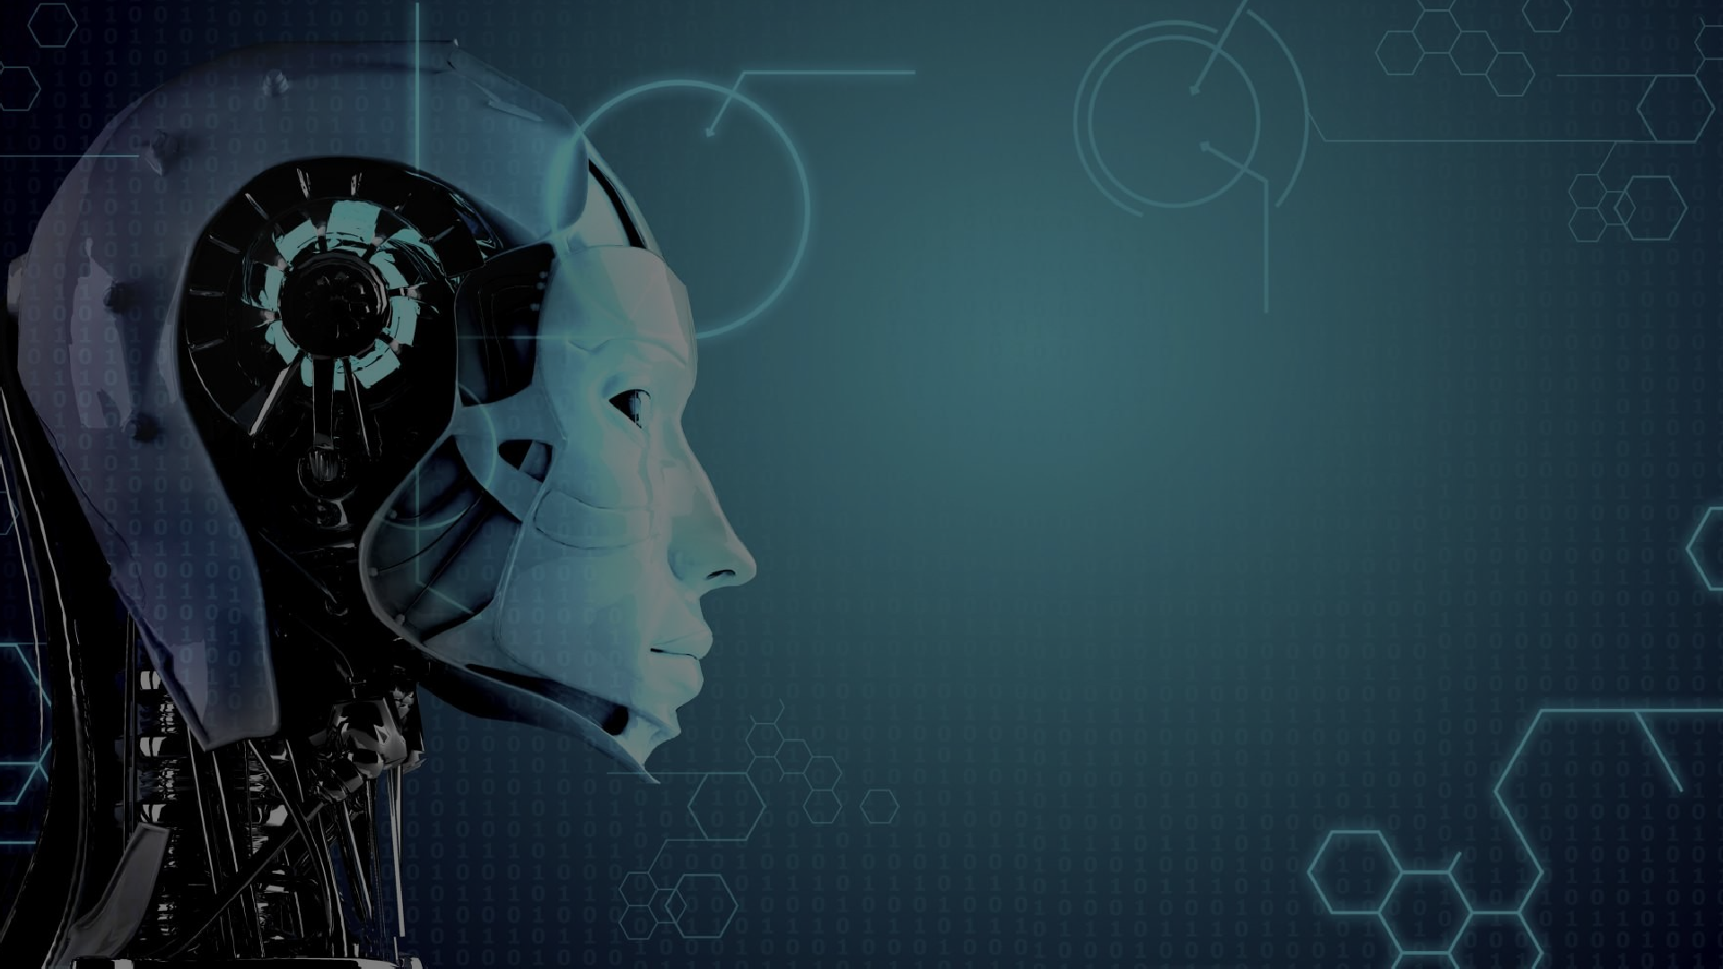

# Artificial Intelligence (AI)

**Shanu Dhali**

**University roll:-28100117038**

**Computer Science and Engineering student**

**Gargi Memorial Institute of Technology**

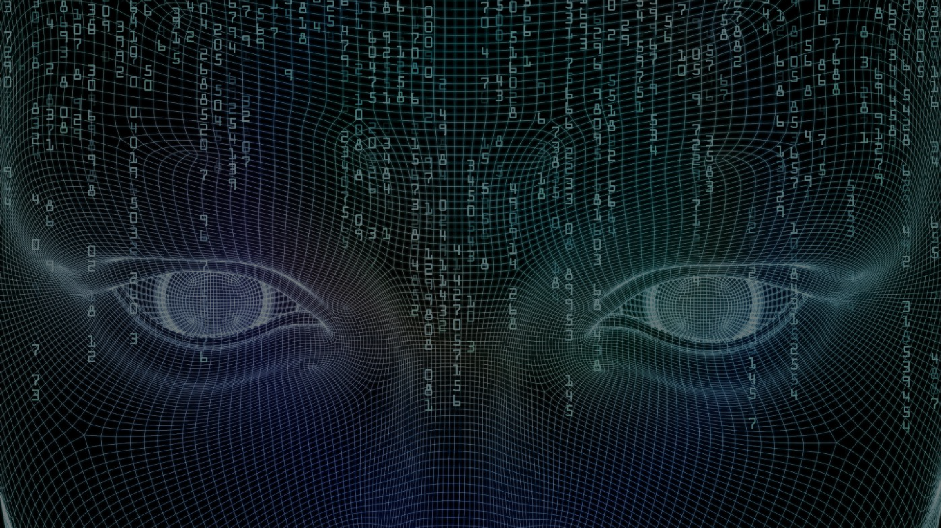

# What do you think Artificial Intelligence is?

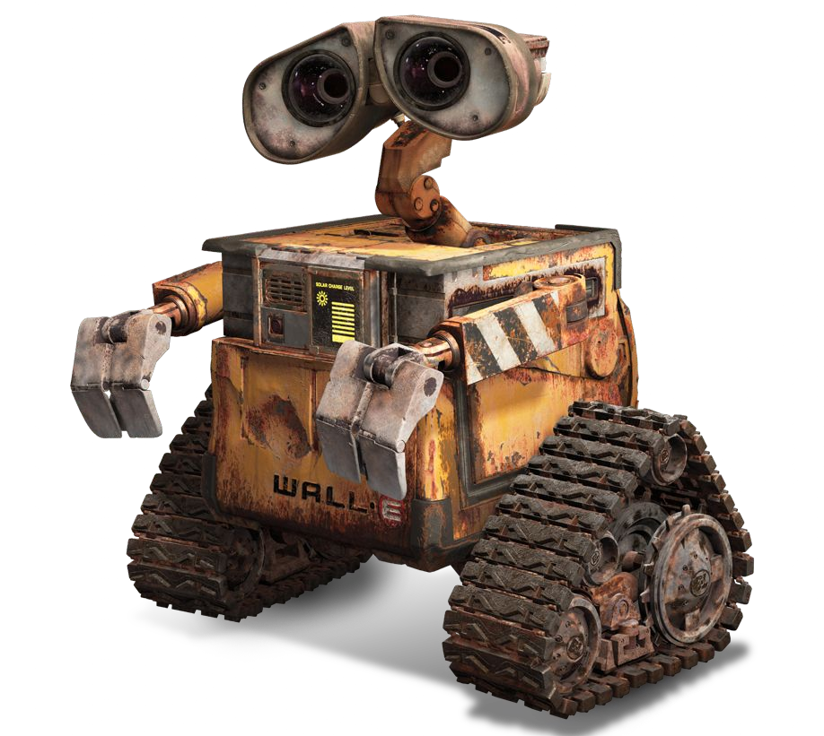

### Artificial Intelligence in Movies

In movies, robots are able to talk, think, have emotions, and make decisions just like humans.

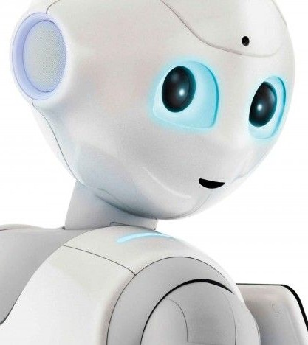

**What is Artificial Intelligence?**

Artificial Intelligence is the development of computer systems that are able to perform tasks that would require human intelligence.

Examples of these tasks are visual perception, speech recognition,

decision-making, and translation between languages.

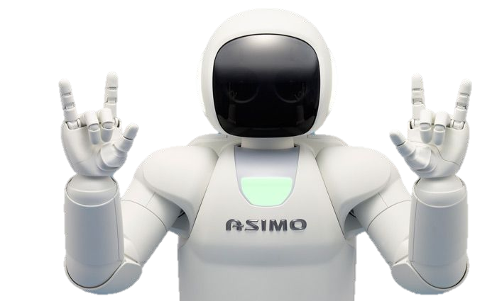

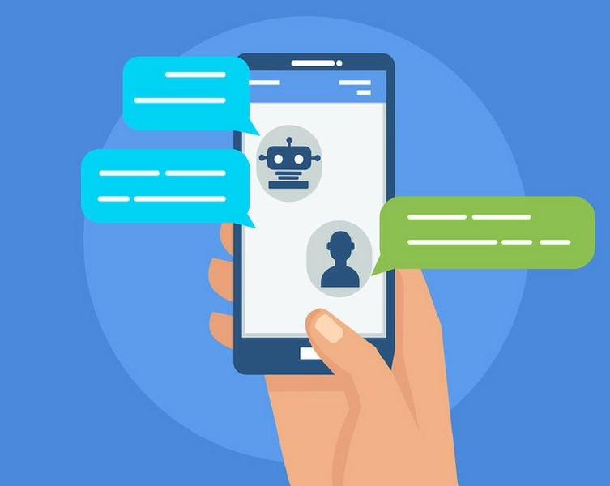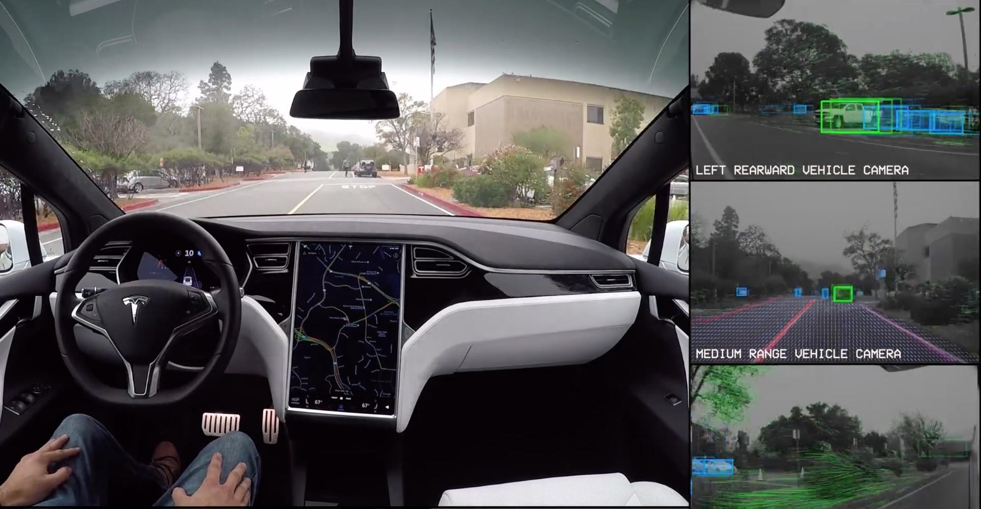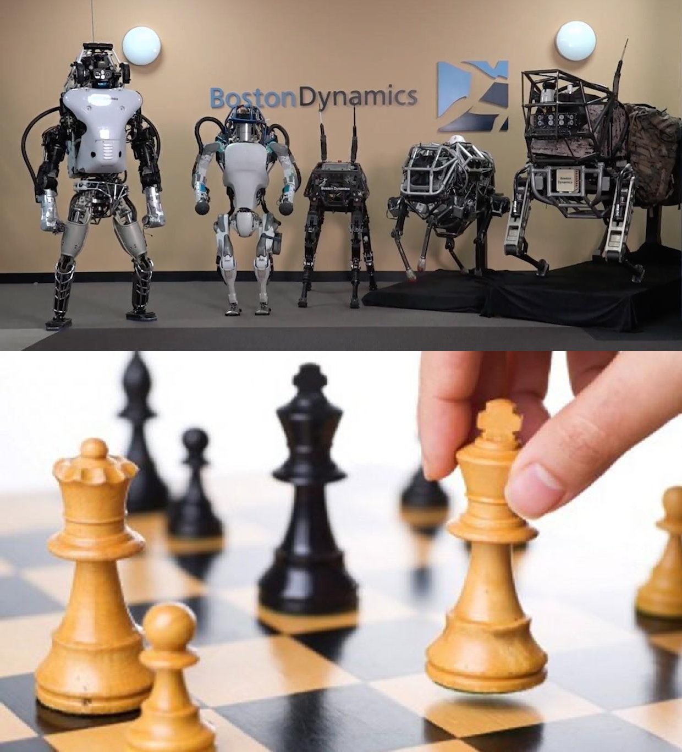

**Real Life A.I. Examples**

* Self Driving Cars
* Boston Dynamics
* Navigation

Systems

* ASIMO
* Chatbots
* Human vs

Computer Games

* Many More!

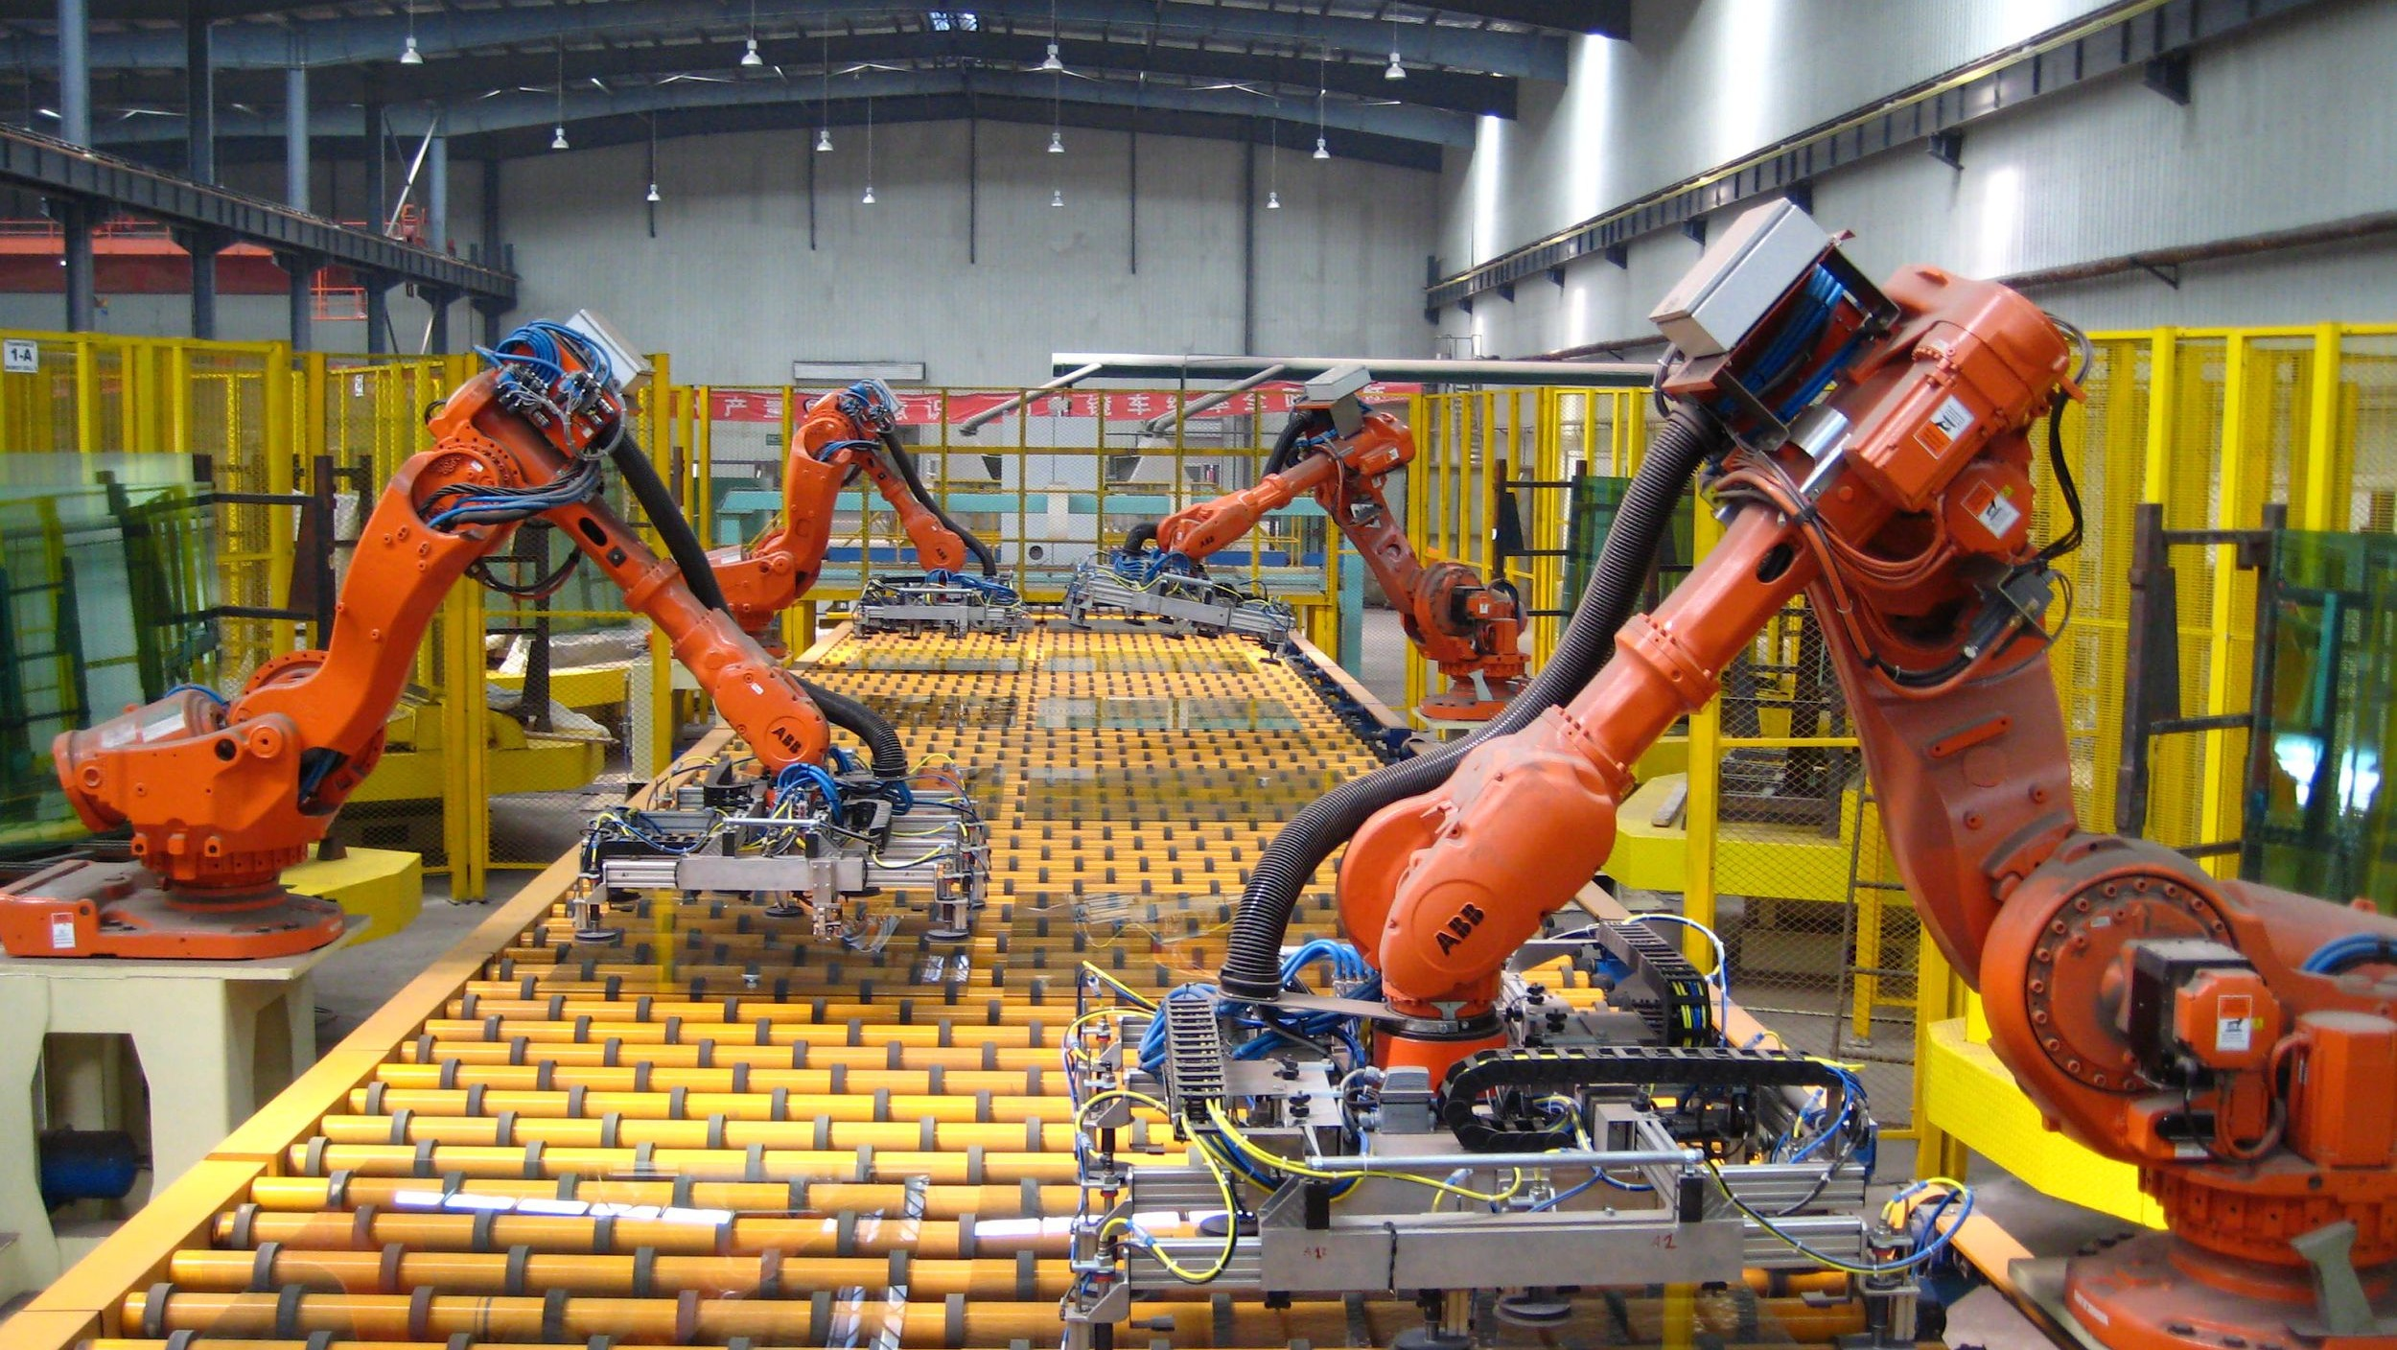

**Weak A.I.**

Machines with weak Artificial Intelligence are made to respond to specific situations, but can not think for themselves

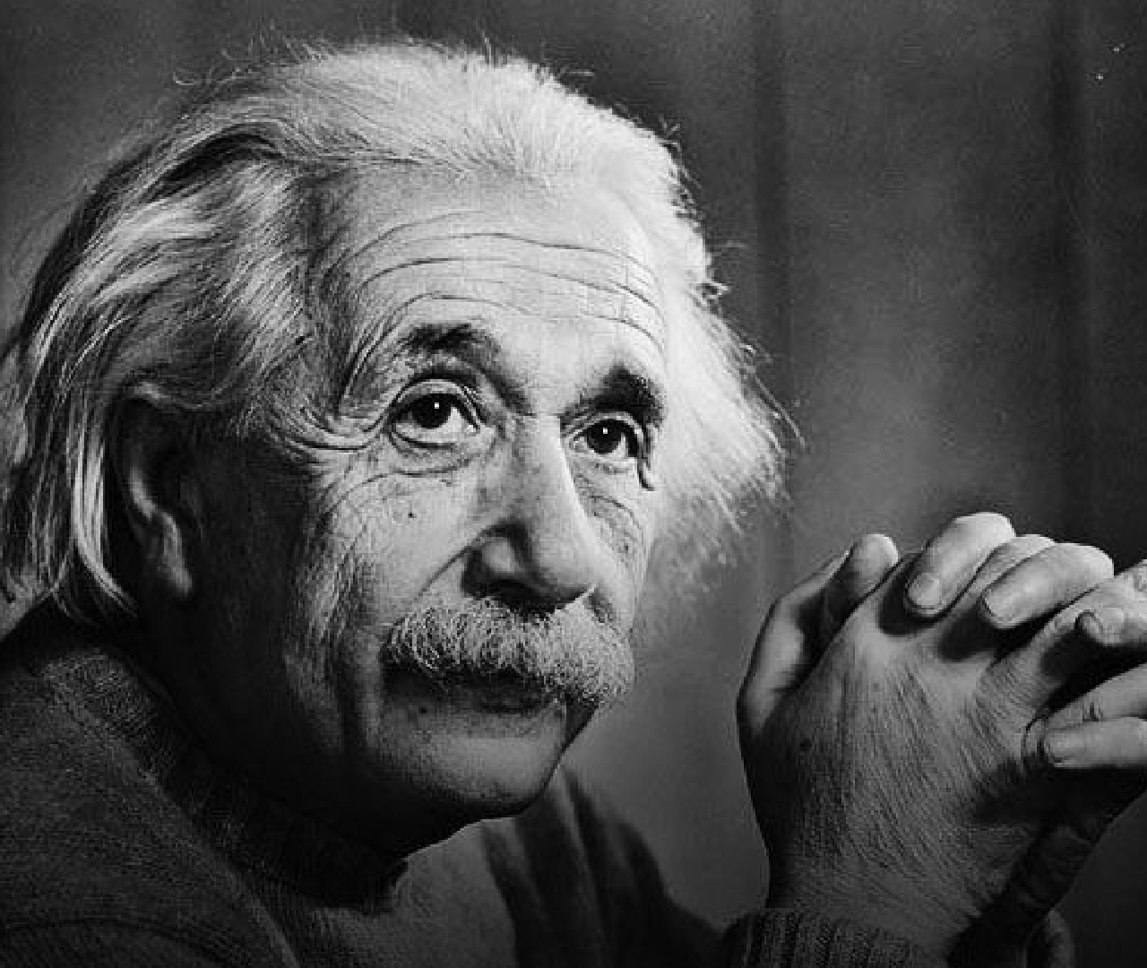

**Strong A.I.**

A machine with strong A.I. is able to think and act just like a human. It is able to learn from experiences.

Since there are no real life examples of strong A.I. yet, the best representation would be how Hollywood portrays robots.

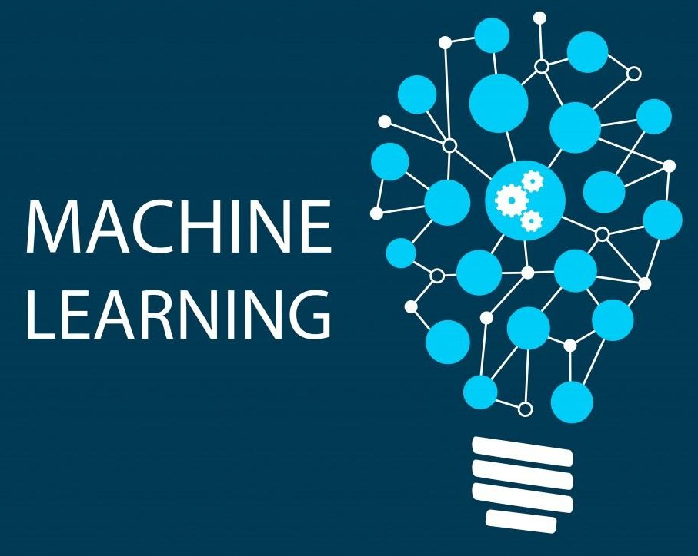

**Machine Learning**

An application of Artificial Intelligence that gives machines the ability to learn and improve without the help of humans or new programming.

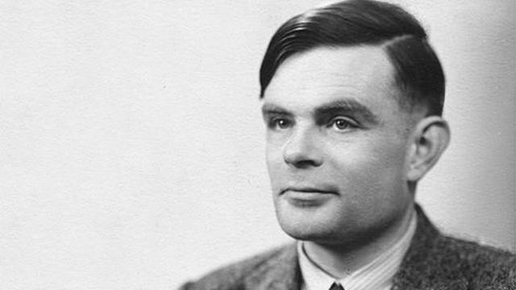

## The Turing Test

In the 1950s Alan Turing created the Turing Test which is used to determine the level of intelligence of a computer.



**Controversy of Turing Test**

Some people disagree with the Turing Test. They claim it does not actually measure a computer's intelligence.

Instead of coming up with a response themselves, they can use the same generic phrases to pass the test.



**The Future of A.I.**

★ Military Bots

★ The perfect lawyer

★ Music

★ Business

★ Healthcare

**Benefits of A.I.**



The most important purpose of

* 1. is to reduce human casualties in

➔ Wars

➔ Dangerous Workspaces

➔ Car Accidents

➔ Natural Disasters

Or to just make everyday life easier by helping with tasks such as:

➔ Cleaning

➔ Shopping

➔ Transportation

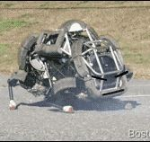**THE END**

**Thank You**

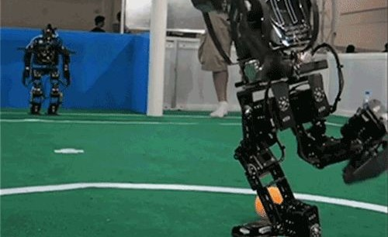



**Sources**

* + - <http://asimo.honda.com/>
    - <https://en.wikipedia.org/wiki/Autonomous_car>
    - [http://www.sciencemag.org/news/2017/08/how-go ogle-making-music-artificial-intelligence](http://www.sciencemag.org/news/2017/08/how-google-making-music-artificial-intelligence)
    - [http://www.legaltechnews.com/id=120279500382 7/Artificial-Intelligence-is-Molding-the-Attorney-of- the-Future?sqlreturn=20170709132104](http://www.legaltechnews.com/id%3D1202795003827/Artificial-Intelligence-is-Molding-the-Attorney-of-the-Future?slreturn=20170709132104)
    - [http://www.newsweek.com/2017/08/18/ai-faceboo k-artificial-intelligence-machine-learning-robots-rob otics-646944.html](http://www.newsweek.com/2017/08/18/ai-facebook-artificial-intelligence-machine-learning-robots-robotics-646944.html)
    - [http://www.nasdaq.com/article/how-alibaba-is-usin g-artificial-intelligence-in-healthcare-cm815551](http://www.nasdaq.com/article/how-alibaba-is-using-artificial-intelligence-in-healthcare-cm815551)